Data Normalization Brief
Standard Scaler vs MinMax Scaler

1. Why Feature Scaling Matters
Machine learning models process all input features using the same mathematical operations. When one feature has values in the range of 20 to 60, and another has values in the range of 10,000 to 150,000, the model does not know these represent different things. It simply sees numbers, and bigger numbers get treated as more important.

This is the scale bias problem. It does not affect every algorithm equally. Tree based models like Random Forest are immune. But distance based and gradient based algorithms, Support Vector Machines, K-Nearest Neighbors, Principal Component Analysis, and Neural Networks produce severely wrong results when features are not scaled.

Feature scaling fixes this by transforming every numerical column into a comparable range before the model sees any data. The two most widely used methods are Standard Scaler and MinMax Scaler. They solve the same problem using fundamentally different mathematics, and choosing the wrong one can break a model entirely.

2. Standard Scaler: Z-Score Standardization

Formula
Standard Scaler transforms every value in a column by subtracting the column mean and dividing by the standard deviation:
Z = (X - μ) / σ
X is the original value. μ (mu) is the column mean. σ (sigma) is the standard deviation. The output Z is the number of standard deviations the value sits away from the average.

Worked Example
Suppose the Age column has a mean of 30 and a standard deviation of 10:
- Age = 50 → Z = (50 - 30) / 10 = +2.0 (2 standard deviations above average)
- Age = 30 → Z = (30 - 30) / 10 = 0.0 (exactly at the average)
- Age = 10 → Z = (10 - 30) / 10 = -2.0 (2 standard deviations below average)

What the Output Guarantees
- The transformed column always has a mean of exactly 0
- The transformed column always has a standard deviation of exactly 1
- There is no fixed minimum or maximum the range depends on data spread
- Outliers become large Z-scores but do not compress or distort other values
- The shape of the distribution is preserved

3. MinMax Scaler: Min-Max Normalization

The Formula
MinMax Scaler maps every value in a column to a fixed range between 0 and 1:
X_scaled = (X - X_min) / (X_max - X_min)
X_min is the smallest value in the column. X_max is the largest. The output is always between 0 and 1, where 0 is the minimum and 1 is the maximum.

Worked Example
Suppose the Age column has a minimum of 18 and a maximum of 65:
- Age = 18 → (18 - 18) / (65 - 18) = 0.000 (minimum, becomes 0)
- Age = 41 → (41 - 18) / (65 - 18) = 0.489 (midpoint maps to ~0.5)
- Age = 65 → (65 - 18) / (65 - 18) = 1.000 (maximum, becomes 1)

What the Output Guarantees
- The minimum value in the column always becomes exactly 0
- The maximum value always becomes exactly 1
- All values are proportionally mapped between 0 and 1
- The shape of the distribution is preserved
- Mean and standard deviation are not fixed they vary based on the data

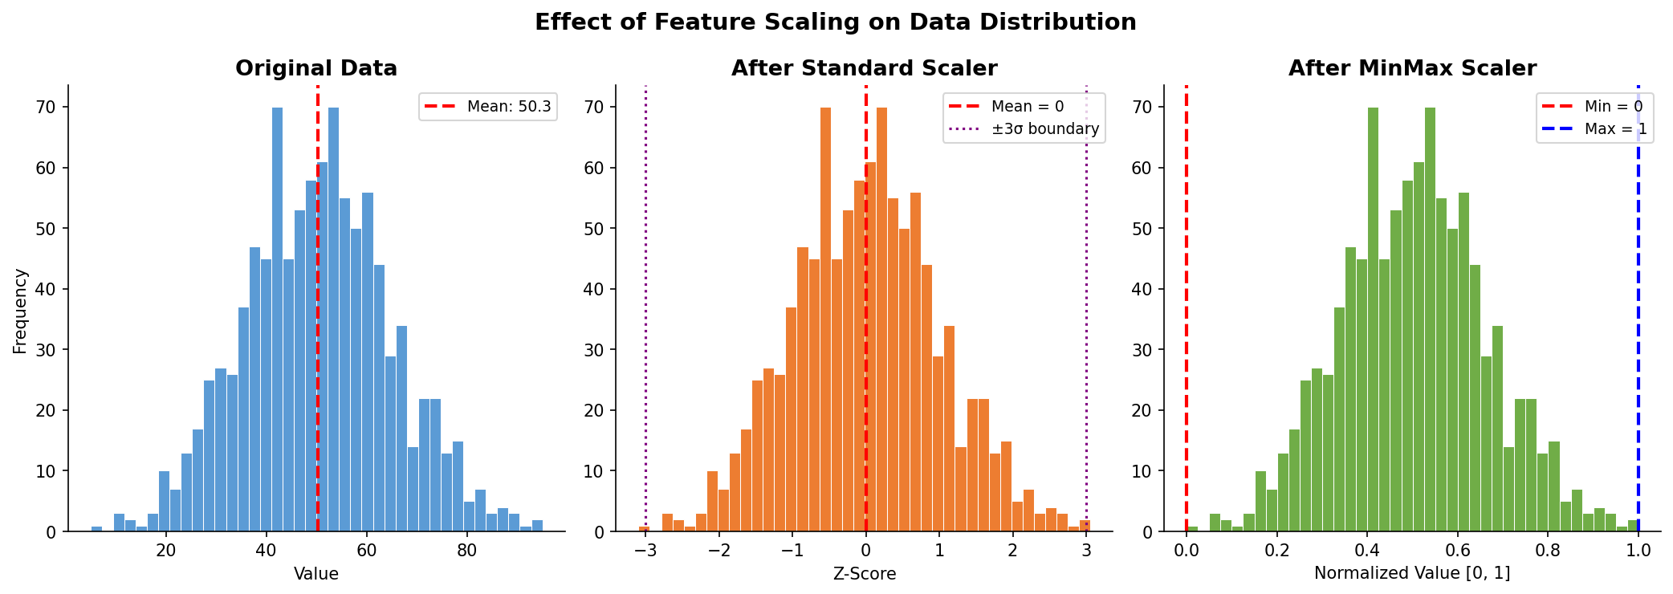

4. Core Mathematical Differences
Property | Standard Scaler | MinMax Scaler
Formula | (X - mean) / std_dev | (X - min) / (max - min)
Output mean | Always exactly 0 | Not fixed
Output std dev | Always exactly 1 | Not fixed
Output range | Unbounded (typically -3 to +3) | Always bounded [0, 1]
Variance equalization | Yes, every feature gets variance = 1 | No, variance differs between features
Effect of one outlier | Outlier becomes large Z; other values unaffected | An outlier compresses all other values toward 0
Distribution shape | Preserved | Preserved
Best for | SVM, PCA, Logistic Regression | Neural Networks, image pixel data

The single most important difference is variance equalization. Standard Scaler forces every feature to have a variance of 1. MinMax Scaler does not. This distinction is what makes Standard Scaler the mathematically correct choice for SVM.

5. The Outlier Problem: Why MinMax Breaks
MinMax Scaler has a critical mathematical vulnerability. Because it anchors its scaling to the minimum and maximum values in the column, a single extreme outlier reshapes the entire scale.
Example: 999 ages between 20 and 60, plus one outlier at age 500. The MinMax formula uses X_min = 20 and X_max = 500. After scaling:
- The valid age range 20–60 maps to the interval 0.000 to 0.083
- All 999 real data points are compressed into just 8.3% of the 0–1 range
- The remaining 91.7% of the scale is wasted, representing one outlier

Standard Scaler handles this correctly. The outlier becomes a large Z-score (around +15), but the mean and standard deviation of the other 999 values are barely affected. The clean data retains its full spread and variation.

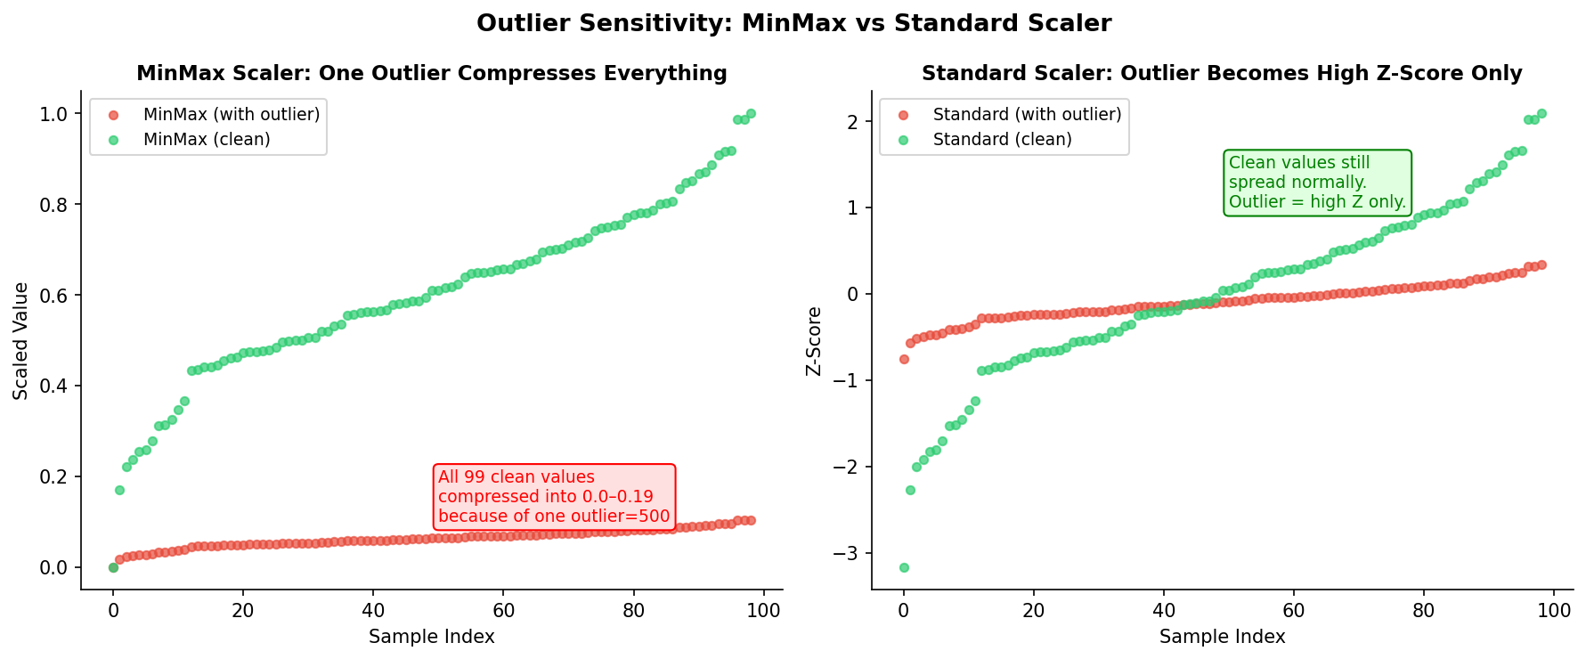
6. Why Wrong Scaling Causes Severe SVM Errors

How SVM Calculates Distance
A Support Vector Machine finds the optimal hyperplane a decision boundary that maximizes the margin between two classes. To do this, it must measure the distance between every pair of data points using the Euclidean distance formula applied across all features simultaneously:
Distance² = (Age_A - Age_B)² + (Income_A - Income_B)² + ...
Every feature contributes to this sum. For the SVM to draw a geometrically correct boundary, every feature must contribute proportionally, which only happens when they have comparable scales.

The Scale Domination Problem
Consider two features with very different scales:
- Age: values between 18 and 65, a range of 47
- Annual Income: values between 20,000 and 150,000 a range of 130,000
If two people differ by 10 years in age and 5,000 in income, their contributions to the squared distance are:
- Age contribution: 10² = 100
- Income contribution: 5,000² = 25,000,000
Income contributes 250,000 times more to the distance calculation than age. For all practical purposes, age has been erased from the model. The SVM draws its entire decision boundary based on income alone not because income is more important, but because its numbers happen to be larger.

Three Specific Failures This Causes
Wrong support vectors:
The support vectors are the data points closest to the decision boundary. With unscaled features, distance is dominated by the high scale feature. The SVM selects the wrong points as support vectors and builds its model on them. The foundation of the model is structurally incorrect.
Incorrect margin maximization:
The optimal hyperplane maximizes the margin across all features. With unscaled data, the SVM maximizes margin in income space while the age dimension is statistically irrelevant. The resulting boundary is geometrically wrong it ignores an entire dimension of the data.
Gamma miscalibration:
The RBF kernel's gamma parameter controls how far the influence of each support vector reaches. Gamma is set based on feature variance. When features have wildly different variances due to scale, gamma is calibrated incorrectly. The kernel becomes either too tight (overfitting every noise point) or too broad (ignoring real patterns), regardless of how much you tune it.

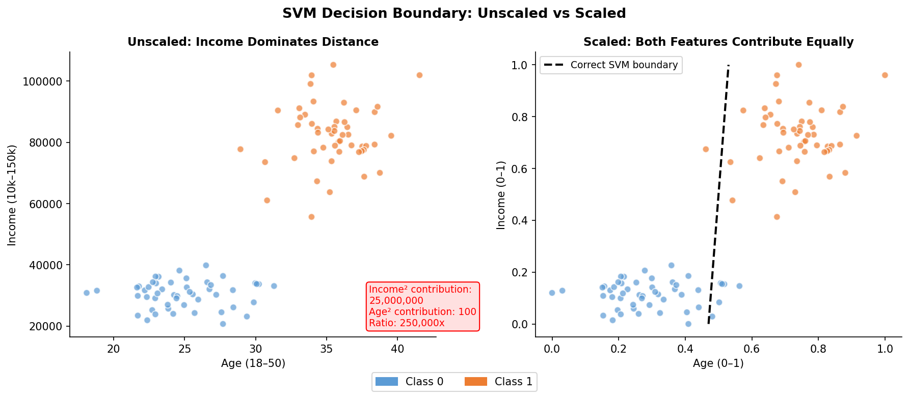

Why Standard Scaler Is the Correct Fix for SVM
After Standard Scaler, every feature has a variance of exactly 1. This means every feature contributes equally to the Euclidean distance calculation, which is the mathematical requirement for SVM to function correctly.
MinMax Scaler is not sufficient. Two features can both be scaled to [0,1] but still have different variances if one is more spread out than the other. The distance calculation would still be distorted. And as shown earlier, a single outlier in one feature would compress that feature into a narrow band, destroying its variance entirely.

7. Summary
Decision Factor | Use Standard Scaler | Use MinMax Scaler
Primary algorithm | SVM, PCA, Logistic Regression | Neural Networks, KNN
Outliers in the dataset | Yes | No
Need bounded output | No | Yes, must be in [0, 1]
Need equal variance | Yes | No
Unknown distribution | Safe choice | Risky without clean data

Choosing the wrong scaling method is not a minor accuracy penalty. For SVM, using unscaled or improperly scaled features produces a structurally invalid model, drawing boundaries based on numerical magnitude rather than statistical relationship. Feature scaling is not optional preprocessing. It is a mathematical requirement for distance based algorithms to produce meaningful results.

Prepared by: Izza Ibrar | 04 June 2026

